

In = = , n = 0,1,2,…

I – current

L ≈ 10-2 cm

ℏ = 1.054\*10-34 J\*s

n = 1

m = 9.1\*10-31 kg

I = 1.6\*10-18A

Φ0 ≈ 4.13567 \* 10-7 Gs\*cm2 ≈ 4.13 \* 10-15 Wb

N – inductance

N = Φ0/I =2581,25 H

ω = 1kHz

C = 3.87\*10-9 F

The equivalent capacity of this bio-circuit is too high to provide high frequency transmission.  
We need to create a secondary circuit to drain some part of the energy sifted through the DNA in the first one, and to make periodic excitation of a specific frequency (the caring frequency of our connector). To enlarge frequency, we have to drop down capacity. Capacity of media between bacteria in colony is dependent on saltiness, temperature and geometric parameters of bacteria. Thus, we can force bacteria to change its size, in response to changes in external environment. For example, pproU promoter in cell is responsible for detecting ocean salt. We can program DNA to react to the concentration of proU by producing more ftsZ – the protein which cause bacteria to grow faster.

We’ve used Klein-Swift model of oceanic water dielectric constant dependency on salt and temperature, and data on quantized magnetics of DNA helix from the paper of (Widom, Swain, Srivastava, Sivsubramanian, 2011).  
We’ve calculated our desired parameters of circuit and ensured it is reachable in real sells.

Then, seen cell as an actuator to adjust capacity.   
Sure, bacteria will move intensively in the media, so a huge variety of distances in between them will occur. But the distribution of these distances in a colony will have some specific most probable value, depending on initial size of bacteria and other factors. Therefore, the colony as a whole will perform as a wavechannel with measurable bandwidth, and the most of bacteria pairs will propagate a signal of a specific wavelength.

Note 2:  
model of water  
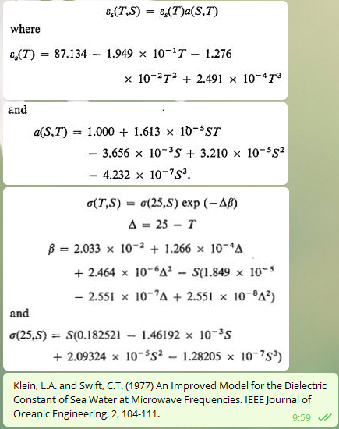

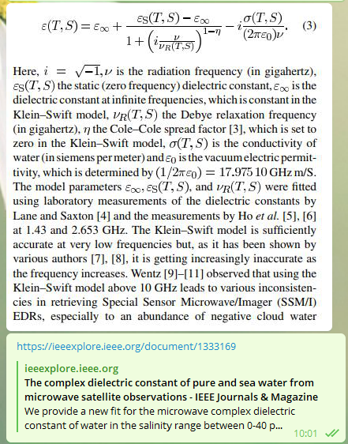

Note 2:

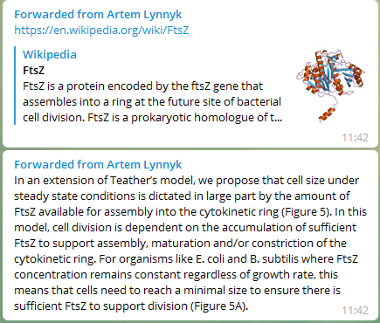

Note 3:

ProU table

